Lab: Data Resources

**Step 1**

Create a UI that looks similar to the following. The data must come from a resource in such a way that adding items to the resource adds items to the UI.

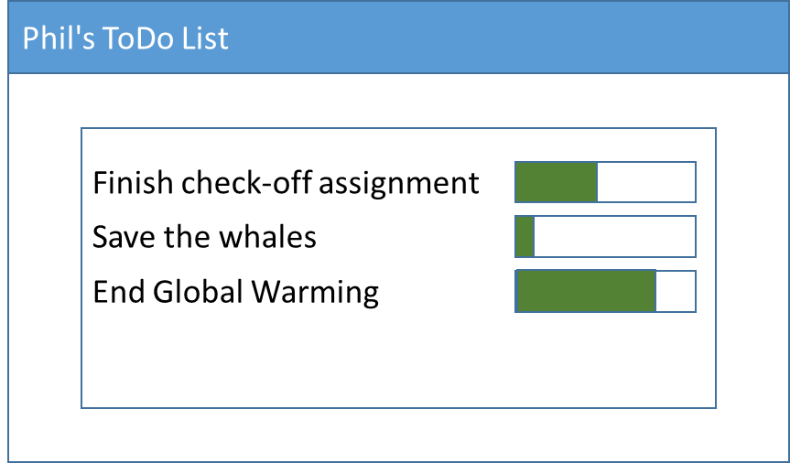

The window must also have a menu that allows you to display an about box.

All text in your application must come from resources. The text shown in the sample window above can come from a <Window.Resources>. All other text must defined in an application resource (in app.xaml)

All appearance must come from style resources. As a minimum, your style sheet must alter the appearance of text and the progress bars. Your style sheet can either be in app.xaml or in a separate xaml file.

**Step 2** (details coming later in the week)

Add a button that initiates a long running process. The process could change the progress on one of the progress bars. The long running process must also update status in the task bar.

Add another UI control that can demonstrate that the UI is still responsive while your long running task is executing.